Ideation Phase

Define the Problem Statements

|  |  |
| --- | --- |
| Date | 30 September 2022 |
| Team ID | PNT2022TMID47921 |
| Project Name | Project - **IoT Based Safety Gadget for Child Safety Monitoring and Notification** |
| Maximum Marks | 2 Marks |

# Customer Problem Statement Template:

Nowadays, crime rate associated with children keeps increasing due to which draws peoples’ attention regarding child safety. This research is conducted to propose a child security smart band utilizing IoT technology. Online questionnaire and semi-structured interview are methodologies used to collect data. The online questionnaire gains feedbacks by sending questions electronically, where answers need to be submitted online. In the semi structured interview, researcher meets and asks respondents some predetermined questions while other being asked are not planned in advanced. Through information obtained, a smart band have been proposed to monitor the safety of children. By this, parents know what is happening remotely and can take actions if something goes wrong. The future improvements of this device will be adding functions and software to make it works like a phone such as messaging, gallery, Google, YouTube, meanwhile, adding more child security features so that child safety is guaranteed.

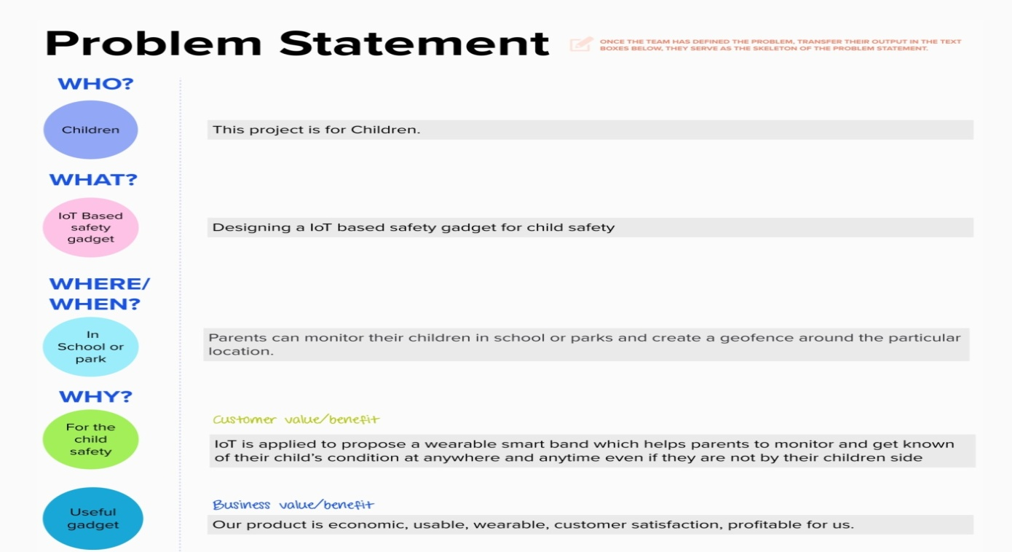

|  |  |  |  |  |  |
| --- | --- | --- | --- | --- | --- |
| **Problem**  **Statement (PS)** | **I am**  **(Customer)** | **I’m trying to** | **But** | **Because** | **Which makes me feel** |
| PS-1 | Parents | Monitor their children without manual intervension | There is no way to look over their children | children cannot complain about abusements which they face in their daily life to their parents so they are worried e to prevent children before being attacked | Parents are responsible for taking care of their own children. But, due to economic condition and aims to focus on their child's future and career, parents are forced to crave for money. |
| PS-2 | Children | Move independently and explore the world | Parents not allowing them alone | to prevent children before being attacked | Due to the abusements, the emotional and mental stability of the children gets affected which in turn ruins their career and future. These innocent children are not responsible for what happens to them |